Project – High Level Design

On

Dockerized Marketing PHP Laravel Service

Course Name: Devops

Institution Name: Medicaps University – Datagami Skill Based Course

Student Name(s) & Enrolment Number(s):
Sr no | Student Name | Enrolment Number
1 | GAURAV RAUNDHALE | EN22IT301036
2 | SANIYA KHAN | EN22IT301091
3 | SOHAM SINGH KUSHWAHA | EN22IT301104
4 | VEDANT MEENA | EN22IT301120

Group Name:08D12
Project Number: DO-46
Industry Mentor Name: Mr.Vaibhav
University Mentor Name:Prof.Akshay Saxena
Academic Year: 2026

Table of Contents
1. Introduction.
1.1. Scope of the document.
1.2. Intended Audience
1.3. System overview.
2. System Design.
2.1. Application Design
2.2. Process Flow.
2.3. Information Flow.
2.4. Components Design
2.5. Key Design Considerations
2.6. API Catalogue.
3. Data Design.
3.1. Data Model
3.2. Data Access Mechanism
3.3. Data Retention Policies
3.4. Data Migration
4. Interfaces
5. State and Session Management
6. Caching
7. Non-Functional Requirements
7.1. Security Aspects
7.2. Performance Aspects
8. References

- Introduction.
  - Scope of the document-
This document outlines the architectural design and technical specifications for containerizing the Marketing Service application. The scope includes the creation of Docker images using multi-stage builds, orchestration via Docker Compose, and the configuration of the runtime environment (application server and database). It does not cover the internal business logic development of the Marketing Service itself, but rather the infrastructure required to run it portably using Python, Flask, and PostgreSQL.

  - Intended Audience-
    - DevOps Engineers: For implementing the CI/CD pipelines and infrastructure setup.
    - Backend Developers: To understand the local development environment and container constraints.
    - System Architects: For reviewing security, scalability, and integration standards.

  - System overview-
    - The system is a containerized web application stack. It decouples the application runtime into distinct, lightweight services:
    - Application Server: A WSGI HTTP Server (like Gunicorn) running the Python/Flask application code.
    - Database: PostgreSQL (persistent storage).
    - These components interact within an isolated Docker network to ensure consistency across Development, Staging, and Production environments.
- System Design
  - Application Design-
- 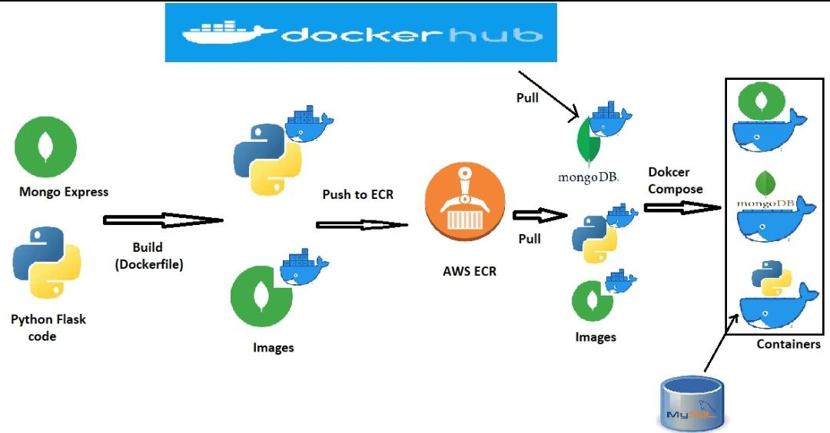

  - Process Flow-
- 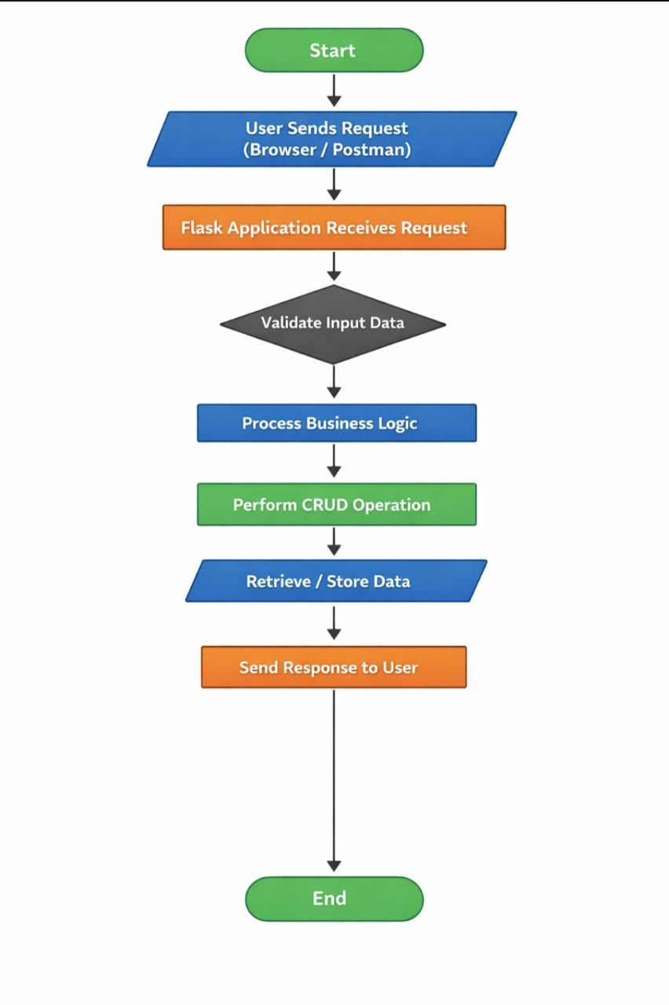

  - Information Flow.
1. 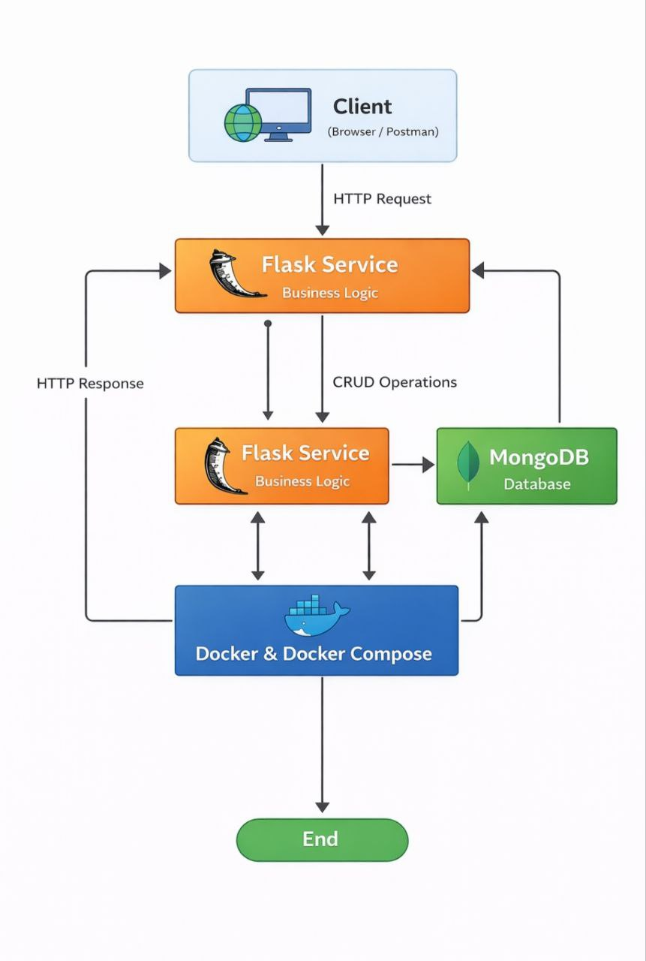

2.4. Components Design
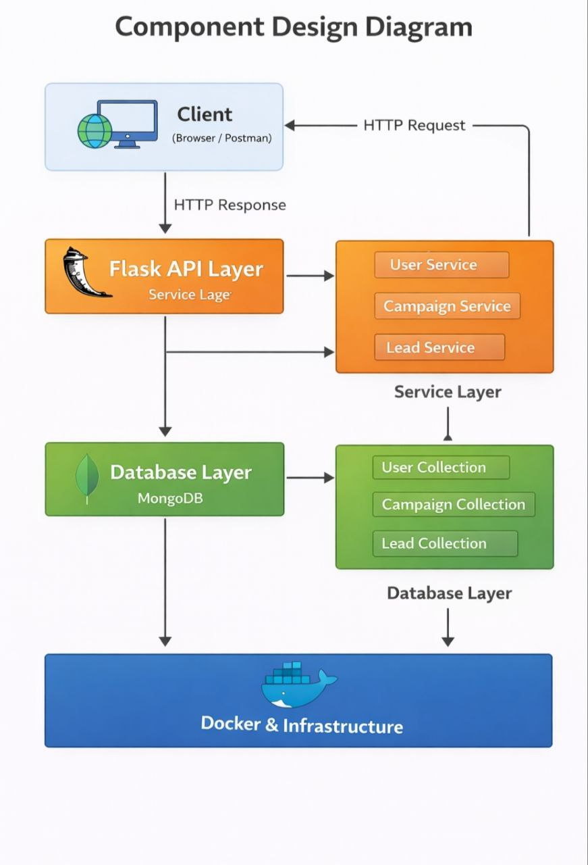

2.5. Key Design Considerations
  - Portability: Using docker-compose.yml ensures developers can spin up the entire stack with one command (docker-compose up).
  - Image Optimization: Utilizing Python slim base images and multi-stage builds to reduce image size (target <200MB).
  - Statelessness: The application containers (Flask) are stateless; ensuring horizontal scalability.

2.6. API Catalogue.
The Marketing Service exposes RESTful endpoints:
  - POST /api/v1/campaigns - Create a new marketing campaign.
  - GET /api/v1/leads - Retrieve generated leads.
  - POST /api/v1/analytics - Ingest click/view data.

- Data Design.
  - Data Model
The PostgreSQL database follows a relational model including:
    - Campaigns Table: Stores campaign details (ID, Name, Budget, Status).
    - Leads Table: Stores customer info captured via campaigns.
    - Logs/Events Table: Stores audit trails for marketing actions.

  - Data Access Mechanism
      - Flask-SQLAlchemy (or a similar
Python ORM) is used for all PostgreSQL database interactions to prevent SQL injection and ensure abstraction.
      - PostgreSQL Database credentials are injected via Environment Variables (.env file in Dev, Kubernetes Secrets in Prod).

  - Data Retention Policies
    - Application Logs: Streamed to stdout/stderr (standard Docker logging) via Python's logging module and collected by a logging driver (e.g., ELK stack or CloudWatch).
    - Database Backups: Scheduled cron jobs run inside a separate utility container to dump PostgreSQL data to external storage (S3/Volume).

  - Data Migration
    - Schema changes are managed via Flask-Migrate (Alembic).
    - A "Migration Job" runs automatically as an initContainer (flask db upgrade) or a pre-deployment step in the CD pipeline to ensure the DB schema is up-to-date before the app starts.

- Interfaces
• User Interface:
A Web Dashboard built using HTML, CSS, and Flask (Jinja2 templates) served through a Dockerized Flask application.
The application can be deployed behind Nginx as a reverse proxy in production environments.
- System Interface:
- Connects to SMTP Servers (e.g., SendGrid, Mailgun, or Gmail SMTP) for sending marketing emails.
- Connects to external Payment Gateway APIs (if billing or subscription features are included).
- Connects to PostgreSQL Database for persistent data storage.
5. State and Session Management
To ensure the Flask containers remain stateless (allowing Kubernetes to scale them up/down freely):
- Sessions: Stored in Redis (instead of local files) to maintain session persistence across multiple containers.
- CSRF Protection: Managed using Flask security mechanisms (such as Flask-WTF or custom token validation), ensuring secure form submission and request validation.
This ensures scalability and proper session
handling in a distributed container environment.
6. Caching
- Application Cache:
Redis is used to cache frequently accessed database queries (e.g., marketing campaign data) to reduce load on PostgreSQL and improve response time.
- Configuration Optimization:
During the Docker build process:
- Python dependencies are pre-installed using requirements.txt
- Production configurations are optimized
- Debug mode is disabled for better runtime performance
This ensures faster startup and improved application efficiency.
- Non-Functional Requirements
7.1 Security Aspects
- Least Privilege Principle:
Containers run as a non-root user inside the Docker image to enhance security.
- Secret Management:
Sensitive data such as database passwords, API keys, and SMTP credentials are not hardcoded.

They are injected using:
- Docker environment variables
- Docker Secrets
- Kubernetes Secrets
- Image Scanning:
The CI/CD pipeline includes vulnerability scanning (e.g., Trivy) to detect security vulnerabilities in Docker base images.
7.2 Performance Aspects
- Horizontal Scaling:
Kubernetes HPA (Horizontal Pod Autoscaler) automatically increases or decreases Flask pods based on traffic load.

- Load Balancing:
Kubernetes services distribute traffic across multiple Flask containers to maintain high availability.
- Efficient Database Connections:
Connection pooling is used to optimize database performance and reduce overhead.
8. References
Flask Documentation: https://flask.palletsprojects.com/
Docker Official Documentation: https://docs.docker.com/
Kubernetes Concepts: https://kubernetes.io/docs/concepts/
12-Factor App Methodology: https://12factor.net/

